**INTERNSHIP**

**PROGRAM REPORT**

[Artificial Intelligence and Machine Learning]

**Industry Partner – Tevatron Technologies Pvt Ltd**



**Hexnbit Online Internship**

**www.hexnbit.com**

*Intern Detail*

Artificial Intelligence and Machine Learning

**Name:** ………………………………………………………………………………………………………………….

Yasaswini Desu

**Name of Intern:**  ………………………………………………………………………………………………………………….

9398189472

**Intern’s Ph. no.:**  ………………………………………………………………………………………………………………….

1-3-28/5A, Yaddanapudivari street, Vidyadarapuram, Vijayawada - 520012

**Intern’s Add.:**  ………………………………………………………………………………………………………………….

SRM University AP

**Name of College:** ………………………………………………………………………………………………………………….

Neerukonda, Mangalagiri, Guntur, Andhra Pradesh 522502

**College’s Add.: ……..**………………………………………………………………………………………………………….

Computer Science and Engineering

**Branch:**  ………………………………………………………………………………………………………………….

**Industry Mentor: Mr. Gagan Preet Singh**

**Designation: R&D Head**

**Company: Hexnbit EdTech Pvt. Ltd**

**Email ID:** [**training@hexnbit.com**](mailto:training@hexnbit.com)

**Contact Number: +91-9818894299**

*Table of content*

|  |  |  |
| --- | --- | --- |
| S.No. | Headings | Page No. |
| 1 | About Company | 1 |
| 2 | List of Software and Modules | 3 |
| 3 | Modules List | 4 |
| 4 | Fundamentals of Python | 5 |
| 5 | Introduction to AIML | 7 |
| 6 | Scientific Toolkit (NumPy and Pandas) | 9 |
| 7 | Data Visualization Toolkit | 12 |
| 8 | Data Visualization: Matplotlib | 13 |
| 9 | Supervised Machine Learning | 14 |
| 10 | Un – Supervised Machine Learning | 17 |
| 11 | Supervised vs Un-supervised Machine | 19 |
| 12 | Introduction to Computer Vision | 20 |
| 13 | Project Report | 22 |
| 14 | List of References | 26 |

*About Tevatron Technologies Pvt. Ltd*

**Tevatron Technologies Pvt Ltd** is a **R&D Design & Services** Company focused on **Artificial Intelligence & Machine learning, Internet of Things (IoT), Embedded Hardware and Software Systems, Sensor and MCUs, VLSI Chip Design and PCB Design covering entire ESDM** space from concept to Productization. We are also a member of **IESA (Indian Electronics Semiconductor Association)**. We are actively working towards **#Make in India** as well as **#Design in India** based initiatives

We have in collaboration with our training division **“Hex N Bit”** to provide Online Industrial Internship program. We have added few out of the box features in our programs like: **Project Tracking using Project Management Tools, Access to Faculty for Monitoring, Mentorship during Project, Live Sessions for Understanding of Concepts, Weekly Assignments to keep track of progress, Industry Expert Webinars, eLearning Modules and Assessments**.

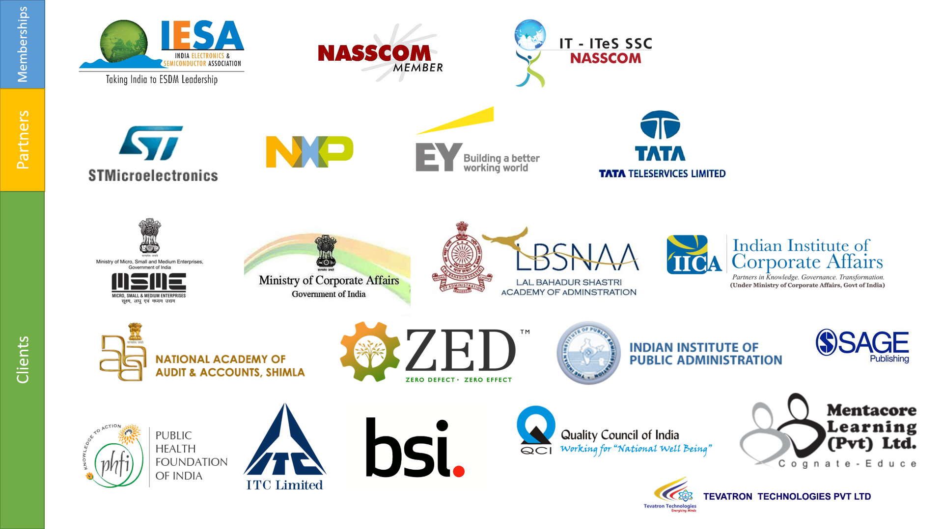

*About Hexnbit EdTech Pvt. Ltd*

* Hexnbit (an ISO certified company) is India’s first Ed-tech company which provides one-stop solutions for the students/Professionals in Industry-connect Skill development courses. The platform not only provides subject expertise to the candidates but also, give them industry exposure to apply their learnings analytically in a practical real-world.
* Having registered over 60,000+ candidates, tied up with 250+ universities, 60+ mentors and 10+ Industry, the company aims to bridge the gap between the academics & Industry by providing them with practical knowledge & analytical skills under one umbrella.
* To reach out to the candidates all over the globe, the company has formed Labs in many institutions so any candidate can learn & grow technically with the mentor support (On-Site support as well as virtual support)
* **Hexnbit is now recognized worldwide recognized by STMicroelectronics (**[**https://www.st.com/en/support-and-applications/technical-training-on-stm32.html**](https://www.st.com/en/support-and-applications/technical-training-on-stm32.html)**)**



*List of Software & Modules used*

**List of Software:**

* Anaconda Navigator
* Jupyter Notebook

**List of Modules/Libraries:**

* NumPy
* Pandas
* Matplotlib
* Seaborn
* Sckit-Learn
* Os Module

*Modules List*

*Fundamentals of Python*

**Description:**

Python is a high-level, interpreted, interactive and object-oriented scripting language. Python is designed to be highly readable. It uses English keywords frequently where as other languages use punctuation, and it has fewer syntactical constructions than other languages.

**Characteristics of Python Programming:**

* It supports functional and structured programming methods as well as OOP.
* It can be used as a scripting language or can be compiled to byte-code for building large applications.
* It provides very high-level dynamic data types and supports dynamic type checking.
* It supports automatic garbage collection.
* It can be easily integrated with C, C++, COM, ActiveX, CORBA, and Java.

**Applications:**

* Python can be used on a server to create web applications.
* Python can be used alongside software to create workflows.
* Python can connect to database systems. It can also read and modify files.
* Python can be used to handle big data and perform complex mathematics.
* Python can be used for rapid prototyping, or for production-ready software development.

**Topics Covered**:

* Getting around Anaconda and Jupyter Notebook
* Python Basics
* Data Types
* Conditional Statements, Loops and Control Statements
* Functions
* Lambda Functions and other built-in functions
* File Handling

*Fundamentals of Python*

**Learning Outcome:**

In this module, exposure was given around the fundamentals of Python Programming to build up a strong foundation. As strong programming foundation will be helpful in data preparation, data preprocessing, analyzing, etc.

*Introduction to AIML*

**What is Artificial Intelligence And Machine Learning?**

Artificial Intelligence is the science and engineering of making intelligent machines, especially intelligent computer programs. Artificial Intelligence is related to the similar task of using computers to understand human intelligence, but AI does not have to confine itself to methods that are biologically observable. The data used for analysis can be from multiple sources and present in various formats.

Artificial Intelligence and Machine Learning are much trending and also confused terms nowadays. Machine Learning (ML) is a subset of Artificial Intelligence. ML is a science of designing and applying algorithms that are able to learn things from the labelled data.  If some behavior exists in the output of the labelled data, then you may predict if or it can happen again. Means if there are no past cases then there is no prediction.

**Why AIML?**

The Artificial intelligence system does not require to be pre-programmed, instead of that, they use such algorithms which can work with their own intelligence. It involves machine learning algorithms such as Reinforcement learning algorithm and deep learning neural networks. AI is being used in multiple places such as chatbots used in the smart phones like Siri, Bixby, Google Assistant.

Based on capabilities, AI can be classified into three types:

* **Weak AI**
* **General AI**
* **Strong AI**

Currently, we are working with weak AI and general AI. The future of AI is Strong AI for which it is said that it will be intelligent than humans.

Machine learning works only for specific domains such as if we are creating a machine learning model to detect pictures of cars, it will only give result for car images, but if we provide a new data like bus image then it will become unresponsive. Machine learning is being used in various places such as for online recommender system, for Google search algorithms, Email spam filter, Facebook Auto friend tagging suggestion, etc.

*Introduction to AIML*

It can be divided into three types:

* **Supervised learning**
* **Reinforcement learning**
* **Unsupervised learning**

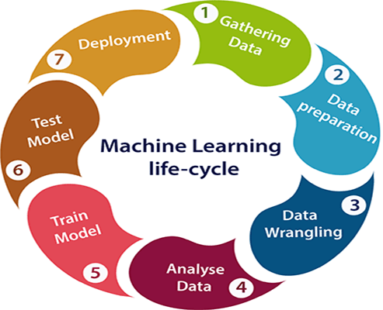

**Learning Outcome:**

In this module, Introduction to Artificial Intelligence And Machine Learning field was given i.e. what is AIML, what are various stages of AIML Life Cycle, etc.

*Scientific Toolkit (Numpy & Pandas)*

**What is NumPy?**

NumPy is the fundamental package for scientific computing in Python. It is a Python library that provides a multidimensional array object, various derived objects (such as masked arrays and matrices), and an assortment of routines for fast operations on arrays, including mathematical, logical, shape manipulation, sorting, selecting, I/O, discrete Fourier transforms, basic linear algebra, basic statistical operations, random simulation and much more.

At the core of the NumPy package, is the Nd array object. This encapsulates n-dimensional arrays of homogeneous data types, with many operations being performed in compiled code for performance. There are several important differences between NumPy arrays and the standard Python sequences:

* NumPy arrays have a fixed size at creation, unlike Python lists (which can grow dynamically). Changing the size of an Nd array will create a new array and delete the original.
* The elements in a NumPy array are all required to be of the same data type, and thus will be the same size in memory. The exception: one can have arrays of (Python, including NumPy) objects, thereby allowing for arrays of different sized elements.
* NumPy arrays facilitate advanced mathematical and other types of operations on large numbers of data. Typically, such operations are executed more efficiently and with less code than is possible using Python’s built-in sequences.
* A growing plethora of scientific and mathematical Python-based packages are using NumPy arrays; though these typically support Python-sequence input, they convert such input to NumPy arrays prior to processing, and they often output NumPy arrays. In other words, in order to efficiently use much (perhaps even most) of today’s scientific/mathematical Python-based software, just knowing how to use Python’s built-in sequence types is insufficient - one also needs to know how to use NumPy arrays.
* The points about sequence size and speed are particularly important in scientific computing. As a simple example, consider the case of multiplying each element in a 1-D sequence with the corresponding element in another sequence of the same length.

*Scientific Toolkit (Numpy & Pandas)*

**What is Pandas?**

Pandas is an open source Python package that is most widely used for data science/data analysis and machine learning tasks. It is built on top of another package named NumPy, which provides support for multi-dimensional arrays. As one of the most popular data wrangling packages, Pandas works well with many other data science modules inside the Python ecosystem, and is typically included in every Python distribution, from those that come with your operating system to commercial vendor distributions like ActiveState’s ActivePython.

**Library Highlights:**

* A fast and efficient Data Frame object for data manipulation with integrated indexing.
* Tools for reading and writing data between in-memory data structures and different formats: CSV and text files, Microsoft Excel, SQL databases, and the fast HDF5 format.
* Intelligent data alignment and integrated handling of missing data: gain automatic label-based alignment in computations and easily manipulate messy data into an orderly form.
* Flexible reshaping and pivoting of data sets.
* Intelligent label-based slicing, fancy indexing, and subsetting of large data sets.
* Columns can be inserted and deleted from data structures for size mutability.
* Aggregating or transforming data with a powerful group by engine allowing split-apply-combine operations on data sets.
* High performance merging and joining of data sets.
* Hierarchical axis indexing provides an intuitive way of working with high-dimensional data in a lower-dimensional data structure.
* Time series-functionality: date range generation and frequency conversion, moving window statistics, date shifting and lagging. Even create domain-specific time offsets and join time series without losing data.
* Python with pandas is in use in a wide variety of academic and commercial domains, including Finance, Neuroscience, Economics, Statistics, Advertising, Web Analytics, and more.

**Topics Covered:**

* **NumPy**  
  NumPy Basics  
  Operations  
  Indexing, Slicing and Copies

*Scientific Toolkit (Numpy & Pandas)*

* **Pandas**Series  
  DataFrames  
  Fix Missing Data  
  GroupBy  
  Merge  
  Operations  
  File Reading and Writing

**Learning Outcome:**

In this module, Introduction to NumPy and Pandas library was given that how these libraries can be helpful in preparing and cleaning data, processing the data, bringing in the insights about the data, data analysis, understanding important features related to business domain, etc.

*Data Visualization Toolkit*

**What is Data Visualization?**

Data visualization is the graphical representation of information and data. By using visual elements like charts, graphs, and maps, data visualization tools provide an accessible way to see and understand trends, outliers, and patterns in data.

In the world of Big Data, data visualization tools and technologies are essential to analyze massive amounts of information and make data-driven decisions.

**Why is Data Visualization important?**

Because of the way the human brain processes information, using charts or graphs to visualize large amounts of complex data is easier than poring over spreadsheets or reports. Data visualization is a quick, easy way to convey concepts in a universal manner – and you can experiment with different scenarios by making slight adjustments.

**Data visualization can also:**

* Identify areas that need attention or improvement.
* Clarify which factors influence customer behavior.
* Help you understand which products to place where.
* Predict sales volumes.

**Common general types of data visualization:**

* Charts
* Tables
* Graphs
* Maps
* Infographics
* Dashboards

**Data visualization can be used for:**

* Making data engaging and easily digestible.
* Identifying trends and outliers within a set of data.
* Telling a story found within the data.
* Reinforcing an argument or opinion.
* Highlighting the important parts of a set of data.

*Data Visualization: Matplotlib*

**What is Matplotlib?**

Matplotlib is a cross-platform, data visualization and graphical plotting library for Python and its numerical extension NumPy. As such, it offers a viable open source alternative to MATLAB. Developers can also use matplotlib’s APIs (Application Programming Interfaces) to embed plots in GUI applications.

A Python matplotlib script is structured so that a few lines of code are all that is required in most instances to generate a visual data plot. The matplotlib scripting layer overlays two APIs:

* The pyplot API is a hierarchy of Python code objects topped by matplotlib.pyplot
* An OO (Object-Oriented) API collection of objects that can be assembled with greater flexibility than pyplot. This API provides direct access to Matplotlib’s backend layers.

One of the greatest benefits of visualization is that it allows us visual access to huge amounts of data in easily digestible visuals. Matplotlib consists of several plots like line, bar, scatter, histogram etc.

**Python Matplotlib : Types of Plots**

There are various plots which can be created using python matplotlib. Some of them are listed below:

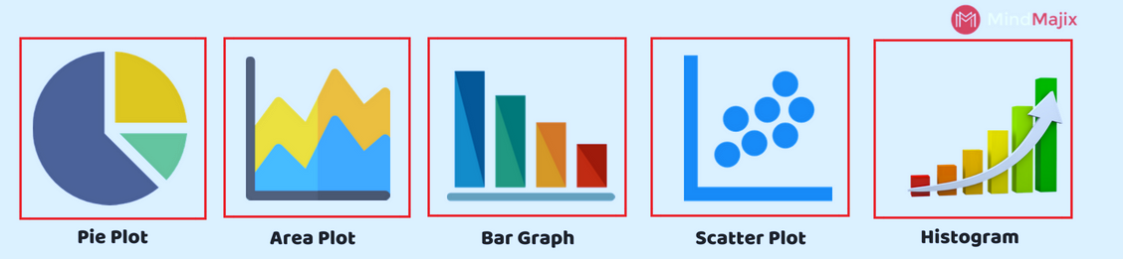

**Learning Outcome:**

In this module, Introduction to Data Visualization was given that how these libraries can be helpful in better understanding of data, bringing in the insights about the data, understanding important features related to business domain, representing facts in compact manner to the stakeholders, etc.

*Supervised Machine Learning*

**What is Supervised Machine Learning?**

* Supervised learning is the types of machine learning in which machines are trained using well "labelled" training data, and on basis of that data, machines predict the output. The labelled data means some input data is already tagged with the correct output.
* In supervised learning, the training data provided to the machines work as the supervisor that teaches the machines to predict the output correctly. It applies the same concept as a student learns in the supervision of the teacher.
* Supervised learning is a process of providing input data as well as correct output data to the machine learning model. The aim of a supervised learning algorithm is to find a mapping function to map the input variable(x) with the output variable(y).
* In the real-world, supervised learning can be used for Risk Assessment, Image classification, Fraud Detection, spam filtering, etc.

**How Supervised Learning Works?**

* In supervised learning, models are trained using labelled dataset, where the model learns about each type of data. Once the training process is completed, the model is tested on the basis of test data (a subset of the training set), and then it predicts the output.

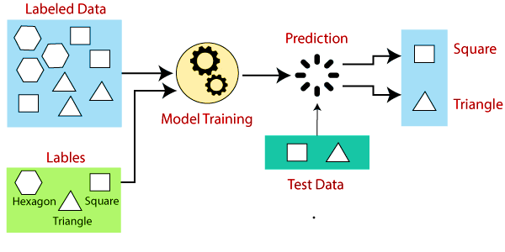

Suppose we have a dataset of different types of shapes which includes square, rectangle, triangle, and Polygon. Now the first step is that we need to train the model for each shape.

* If the given shape has four sides, and all the sides are equal, then it will be labelled as a Square.
* If the given shape has three sides, then it will be labelled as a triangle.
* If the given shape has six equal sides then it will be labelled as hexagon.

*Supervised Machine Learning*

Now, after training, we test our model using the test set, and the task of the model is to identify the shape.

The machine is already trained on all types of shapes, and when it finds a new shape, it classifies the shape on the bases of a number of sides, and predicts the output.

**Types of supervised Machine learning Algorithms:**

Supervised learning can be further divided into two types of problems:

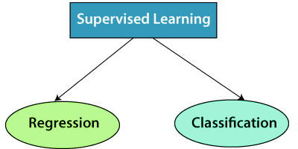

**1. Regression**

Regression algorithms are used if there is a relationship between the input variable and the output variable. It is used for the prediction of continuous variables, such as Weather forecasting, Market Trends, etc. Below are some popular Regression algorithms which come under supervised learning:

* Linear Regression
* Regression Trees
* Non-Linear Regression
* Bayesian Linear Regression
* Polynomial Regression

**2. Classification**

Classification algorithms are used when the output variable is categorical, which means there are two classes such as Yes-No, Male-Female, True-false, etc.

* Spam Filtering,
* Random Forest
* Decision Trees
* Logistic Regression
* Support vector Machines

*Supervised Machine Learning*

**Advantages of Supervised learning:**

* With the help of supervised learning, the model can predict the output on the basis of prior experiences.
* In supervised learning, we can have an exact idea about the classes of objects.
* Supervised learning model helps us to solve various real-world problems such as fraud detection, spam filtering, etc.

**Disadvantages of supervised learning:**

* Supervised learning models are not suitable for handling the complex tasks.
* Supervised learning cannot predict the correct output if the test data is different from the training dataset.
* Training required lots of computation times.
* In supervised learning, we need enough knowledge about the classes of object.

**Topics Covered:**

* Machine Learning with Python
* Supervised- Linear Regression
* Supervised- Logistic Regression
* Supervised- Decision Tree
* Supervised- Support Vector Machine
* Supervised– K-Nearest Neighbours

**Learning Outcome:**

In this module, Introduction to supervised learning was given that how these libraries can be helpful in building up the prediction models using different algorithms for different business use cases, improving the models, etc.

*Un-Supervised Machine Learning*

**What is Un-Supervised Machine Learning?**

* As the name suggests, unsupervised learning is a machine learning technique in which models are not supervised using training dataset. Instead, models itself find the hidden patterns and insights from the given data. It can be compared to learning which takes place in the human brain while learning new things. It can be defined as:
* Unsupervised learning is a type of machine learning in which models are trained using unlabeled dataset and are allowed to act on that data without any supervision.
* Unsupervised learning cannot be directly applied to a regression or classification problem because unlike supervised learning, we have the input data but no corresponding output data. The goal of unsupervised learning is to find the underlying structure of dataset, group that data according to similarities, and represent that dataset in a compressed format.

**How Un-Supervised Learning Works?**

Working of unsupervised learning can be understood by the below diagram:

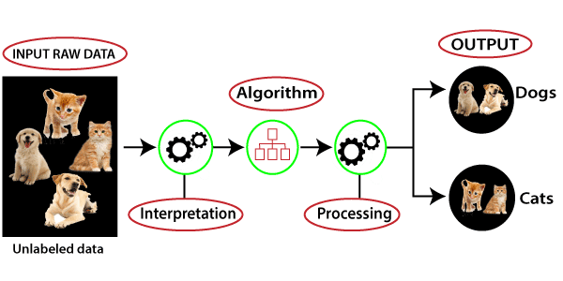

Here, we have taken an unlabeled input data, which means it is not categorized and corresponding outputs are also not given. Now, this unlabeled input data is fed to the machine learning model in order to train it. Firstly, it will interpret the raw data to find the hidden patterns from the data and then will apply suitable algorithms such as k-means clustering, Decision tree, etc.

Once it applies the suitable algorithm, the algorithm divides the data objects into groups according to the similarities and difference between the objects.

*Un-Supervised Machine Learning*

**Types of Unsupervised Learning Algorithm:**

The unsupervised learning algorithm can be further categorized into two types of problems:

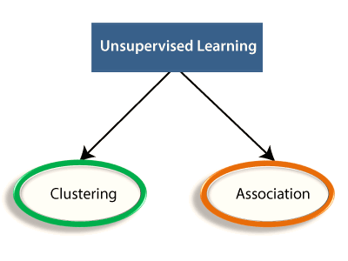

1. **Clustering:**

Clustering is a method of grouping the objects into clusters such that objects with most similarities remains into a group and has less or no similarities with the objects of another group. Cluster analysis finds the commonalities between the data objects and categorizes them as per the presence and absence of those commonalities.

1. **Association:**

An association rule is an unsupervised learning method which is used for finding the relationships between variables in the large database. It determines the set of items that occurs together in the dataset. Association rule makes marketing strategy more effective. Such as people who buy X item (suppose a bread) are also tend to purchase Y (Butter/Jam) item. A typical example of Association rule is Market Basket Analysis.

**Advantages of Unsupervised Learning**

* Unsupervised learning is used for more complex tasks as compared to supervised learning because, in unsupervised learning, we don't have labeled input data.
* Unsupervised learning is preferable as it is easy to get unlabeled data in comparison to labeled data.

**Disadvantages of Unsupervised Learning**

* Unsupervised learning is intrinsically more difficult than supervised learning as it does not have corresponding output.
* The result of the unsupervised learning algorithm might be less accurate as input data is not labeled, and algorithms do not know the exact output in advance.

*Supervised vs Un-Supervised Learning*

|  |  |
| --- | --- |
| Supervised Learning | Un-Supervised Learning |
| Supervised learning algorithms are trained using labeled data. | Unsupervised learning algorithms are trained using unlabeled data. |
| Supervised learning model takes direct feedback to check if it is predicting correct output or not. | Unsupervised learning model does not take any feedback. |
| Supervised learning model predicts the output. | Unsupervised learning model finds the hidden patterns in data. |
| In supervised learning, input data is provided to the model along with the output. | In unsupervised learning, only input data is provided to the model. |
| The goal of supervised learning is to train the model so that it can predict the output when it is given new data. | The goal of unsupervised learning is to find the hidden patterns and useful insights from the unknown dataset |
| Supervised learning can be categorized in Classification and Regression problems. | Unsupervised Learning can be classified in Clustering and Associations problems. |
| Supervised learning can be used for those cases where we know the input as well as corresponding outputs. | Unsupervised learning can be used for those cases where we have only input data and no corresponding output data. |
| It includes various algorithms such as Linear Regression, Logistic Regression, Support Vector Machine, Multi-class Classification, Decision tree, Bayesian Logic, etc. | It includes various algorithms such as Clustering, KNN, and Apriori algorithm. |

*Introduction To Computer Vision*

**Introduction to Computer Vision:**

Computer vision is a field of study which enables computers to replicate the human visual system. It’s a subset of artificial intelligence which collects information from digital images or videos and processes them to define the attributes. The entire process involves image acquiring, screening, analyzing, identifying and extracting information. This extensive processing helps computers to understand any visual content and act on it accordingly.   
Computer vision projects translate digital visual content into explicit descriptions to gather multi-dimensional data. This data is then turned into computer-readable language to aid the decision-making process. The main objective of this branch of artificial intelligence is to teach machines to collect information from pixels.

**How Does Computer Vision Works?**

Computer Vision primarily relies on pattern recognition techniques to self-train and understand visual data. The wide availability of data and the willingness of companies to share them has made it possible for deep learning experts to use this data to make the process more accurate and fast. While machine learning algorithms were previously used for computer vision applications, now deep learning methods have evolved as a better solution for this domain. Because machine learning techniques require a humongous amount of data and active human monitoring in the initial phase monitoring to ensure that the results are as accurate as possible. While Deep learning on the other hand, relies on neural networks, and uses examples for problem solving. It self-learns by using labeled data to recognize common patterns in the examples. Computer Vision algorithm used in the self-driving autonomous sophisticated cars like Tesla. These types of cars aim at reducing the need for human intervention while driving, through various AI systems. Computer vision is part of such a system which focuses on imitating the logics behind human vision to help the machines take data-based decisions. CV systems will scan live objects and categorize them, based on which the car will keep running or make a stop. If the car comes across an obstacle or a traffic light, it will analyze the image, create a 3D version of it, consider the features and decide on an action- all within a second.

**Topics Covered:**

* Introduction to OpenCV with Python and basic operations
* Basic Arithmetic operations on live photos and live videos.

*Introduction To Computer Vision*

* Live Video stream using OpenCV and object detection
* Basic Face, Eyes, Nose and Smile detection Algorithm using Cascade Classifier

**Learning Outcome:**

In this module, Introduction to OpenCV was given how the basic operations of cv2 utilized for real time object detection like vehicle detection, Face mask detection, etc.

*Project Report*

**Abstract:**

The purpose is to classify a given silhouette as one of four types of vehicles, using a set of features extracted from the silhouette. The vehicle may be viewed from one of many different angles.

**Dataset Description:**

The features were extracted from the silhouettes by the HIPS (Hierarchical Image Processing System) extension BINATTS, which extracts a combination of scale independent features utilizing both classical moments-based measures such as scaled variance, skewness and kurtosis about the major/minor axes and heuristic measures such as hollows, circularity, rectangularity and compactness.

Four "Corgie" model vehicles were used for the experiment: a **double decker bus, Chevrolet van, Saab 9000 and an Opel Manta 400**. This particular combination of vehicles was chosen with the expectation that the bus, van and either one of the cars would be readily distinguishable, but it would be more difficult to distinguish between the cars

**Attributes:**

We have 19 columns in the dataset:

Compactness, circularity, distance_circularity, radius_ratio, pr.axis_aspect_ratio, max.length_aspect_ratio, scatter_ratio, elongtedness, pr.axis_rectangularity, max.length_rectangularity, scaled_variance, scaled_variance.1, scaled_radius_of_gyration, scaled_radius_of_gyration_1, skewness_about, skeweness_about.1, skewness_about.2, hollows_ratio, class.

**Domain:**

Object Detection (Vehicle).

**Steps and Tasks:**

1. **Data Preprocessing**: We have performed Exploratory data analysis and came to conclusion by understanding different plots and checked if there is any missing data.
2. We have used **heat map** of correlation and to understand the attributes which are highly correlated.
3. And used various models to predict the data.

*Project Report*

**Classifiers:**

1. **Logistic Regression:**

Logistic regression is a statistical method for predicting binary classes. predicts the probability of occurrence of a binary event utilizing a logit function.

**How Logistic Regression Algorithm works:**

* Select the best attribute using Attribute Selection Measures (ASM) to split the records.
* Split the data and train/test the model by importing train_test_split from skit-learn.
* Train the model using LogisticRegression () and then predict the values.
* At last, evaluate the data by finding accuracy, recall, precision value etc.

1. **Decision Tree Classifier:**

A decision tree is a flowchart-like tree structure where an internal node represents feature, the branch represents a decision rule and each leaf node represents the outcome.

**How Decision Tree Classifier Algorithm works:**

* Select the best attribute using Attribute Selection Measures (ASM) to split the records
* Make that attribute as a decision node and breaks the remaining dataset into smaller chunks.
* As above split the data and train the model by importing train_test_split from skit-learn.
* Train the model using DecisionTreeClassifier () and then predict the values.
* At last, evaluate the data by finding accuracy, recall, precision value etc.

1. **Support Vector Classifier (SVM):**

It is a set of supervised learning methods used for classification, regression and outlier’s detection. The Main objective of SVM is finding a hyperplane that divides a dataset into two classes.

**How Support Vector Classifier Algorithm works:**

* Select the best attribute using Attribute Selection Measures (ASM) to split the records.
* Repeat the data splitting steps as in 1 and 2, and then predict the values using SVC () method.
* Usually, the accuracy with this algorithm is low, so we will hyper parameters to tune the algorithm using GridSearch.
* Then if we use GridSearchCV () algorithm to predict the values, the accuracy will increase to some extent.
* We can consider that as the final accuracy for that model.

*Project Report*

1. **K Means:**

K-Means Clustering is an unsupervised learning algorithm that is used to solve the clustering problems in machine learning or data science. This algorithm groups the unlabeled dataset into different clusters.

The k-means clustering algorithm mainly performs two tasks:

* Determines the best value for K center points or centroids by an iterative process.
* Assigns each data point to its closest k-center. Those data points which are near to the particular k-center, create a cluster. Hence each cluster has datapoints with some commonalities, and it is away from other clusters

**How K Means Classifier Algorithm works:**

* Select the best attribute using Attribute Selection Measures (ASM) to split the records.
* First, initialize K Means and cluster the data categorize them.
* Now compare the clustered values and actual values which gives us the accuracy.

**Conclusion:**

**Best Tuning Algorithm:**

Comparing all the models, we conclude that **Logistic Regression**, **Decision Tree Classifier** and **SVM** gives better results when compared to SVM (before tuning) and KMeans.  
  
So we will use either of the above models to predict the silhouette as one of the four types of vehicles.

**Project Summary:**

* The vs.csv data was processed for null values, duplicate values and Outliers.
* Correlation among the various features are observed.
* From Elbow Curve we observed the characteristics of the data shared along the explained variance and Principle components.
* We have used 4 models namely Logistic Regression, Decision Tree Classifier, SVM, K Means to predict to the data without reducing features to understand the data and model behavior.
* Among all those we found that Logistic Regression, Decision Tree and SVM (after tuning) gave better results.

*Project Report*

**Future scope of improvement in the algorithm:**

This dataset deals with the classification of vehicles, we can further develop this by using Open CV and Deep Learning which is one of the easiest possible ways to identify the type of vehicle.

*List of References*

* [https://matplotlib.org/stable/gallery/index.html#](https://matplotlib.org/stable/gallery/index.html)
* <https://www.tableau.com/learn/articles/data-visualization>
* <https://pandas.pydata.org/>
* <https://numpy.org/>
* <https://www.javatpoint.com/machine-learning>
* <https://www.python.org/>
* <https://www.hexnbit.com/>
* <https://www.tevatrontech.com/>
* <https://scikit-learn.org/stable/>